**Refactor @GetMapping and @PostMapping**

**GetMapping and PostMapping**:

The @GetMapping and @PostMapping annotation are recently added in Spring framework. Now we will apply this in our code.

**Http Request / Response:**

When we send data over to a Spring MVC controller, we normally have an HTML form. We send over a request. The controller will process it and send us back a response.

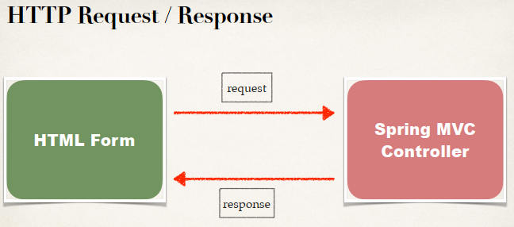

**Most Commonly Used HTTP Method**:

|  |  |  |
| --- | --- | --- |
| **Ser. No** | **Method** | **Description** |
| 1 | GET | Requests data from given resource |
| 2 | POST | Submits data to given resource |
| 3 | PUT | Update data in the given resource |
| 4 | DELETE | Delete data from the given resource |

**Sending data with Get method**:

To send over data with Get method, we set up our form and the key item here is we set "**method = Get**". In this case, when the form data is submitted, it’s actually appended to the end of the URL as name/value pair.

<form action="processForm" method="GET" …> …</form>

So, we have an URL with a question mark and then we will have field1 value1 and field2 value2….

theUrl?field1=value1&field2=value2…

**Handling Form Submission**:

**@RequestMapping("/processForm")  
 public String processForm(...) {  
 ...  
}**

This mapping handles ALL HTTP methods GET, POST, PUT, DELETE, etc.

Now to handling a form submission, we already do this in our Spring MVC code. We simply set up an @RequestMapping and we give the actual path.

**Constrain the Request Mapping – GET**:

1. This mapping ONLY handles GET method.
2. Any other HTTP REQUEST method will get rejected.

**@RequestMapping(path="/processForm", method=RequestMethod.GET)  
 public String processForm(...) {  
 ...  
}**

**New Annotation Short-Cut (GET)**:

**@GetMapping("/processForm")  
 public String processForm(...) {  
 ...  
}**

* New annotation: @GetMapping
* This mapping ONLY handles GET method
* Any other HTTP REQUEST method will get rejected

**Sending Data with POST method**:

<form action="processForm" method="POST" …> …</form>

* Form data is passed in the body of HTTP request message

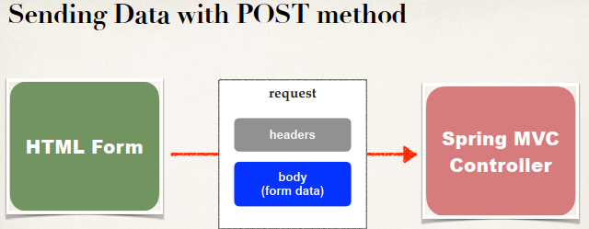

**Constrain the Request Mapping – POST**:

**@RequestMapping(path="/processForm", method=RequestMethod.POST)  
 public String processForm(...) {  
 ...  
}**

* This mapping ONLY handles POST method
* Any other HTTP REQUEST method will get rejected

**New Annotation Short-Cut (POST)**:

**@PostMapping("/processForm")  
 public String processForm(...) {  
 ...  
}**

* New annotation: @PostMapping
* This mapping ONLY handles POST method
* Any other HTTP REQUEST method will get rejected

Refactor @GetMapping and @PostMapping